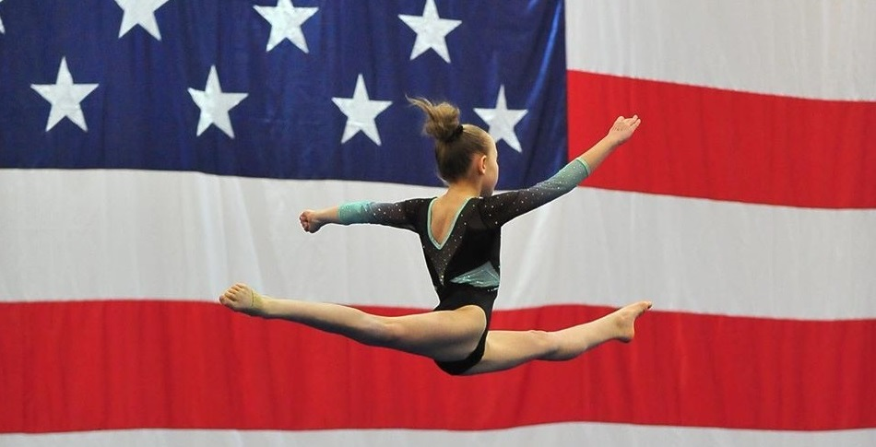
2024
Trampoline & Tumbling Camp
August 6 & 8
9:00 –12:00

Team Camp
July 15 – 18
9:00 – 3:00

Level 2 – Advanced Camp
July 22, 23, 25
9:00 – 1:00
JUNE
JULY
GGAC SUMMER CAMPS
Ninja Camp
June 18 & 20
9:00-12:00

Beginner-Intermediate Camp
June 18 & 20
9:00 – 12:00
AUGUST
Limited enrollment. Camps will fill quickly. Deposit MUST be turned in with registration form to hold your spot. Download forms at greenvillegymnasticsacademy.com

724.588.8166
REGISTRATION OPEN!!
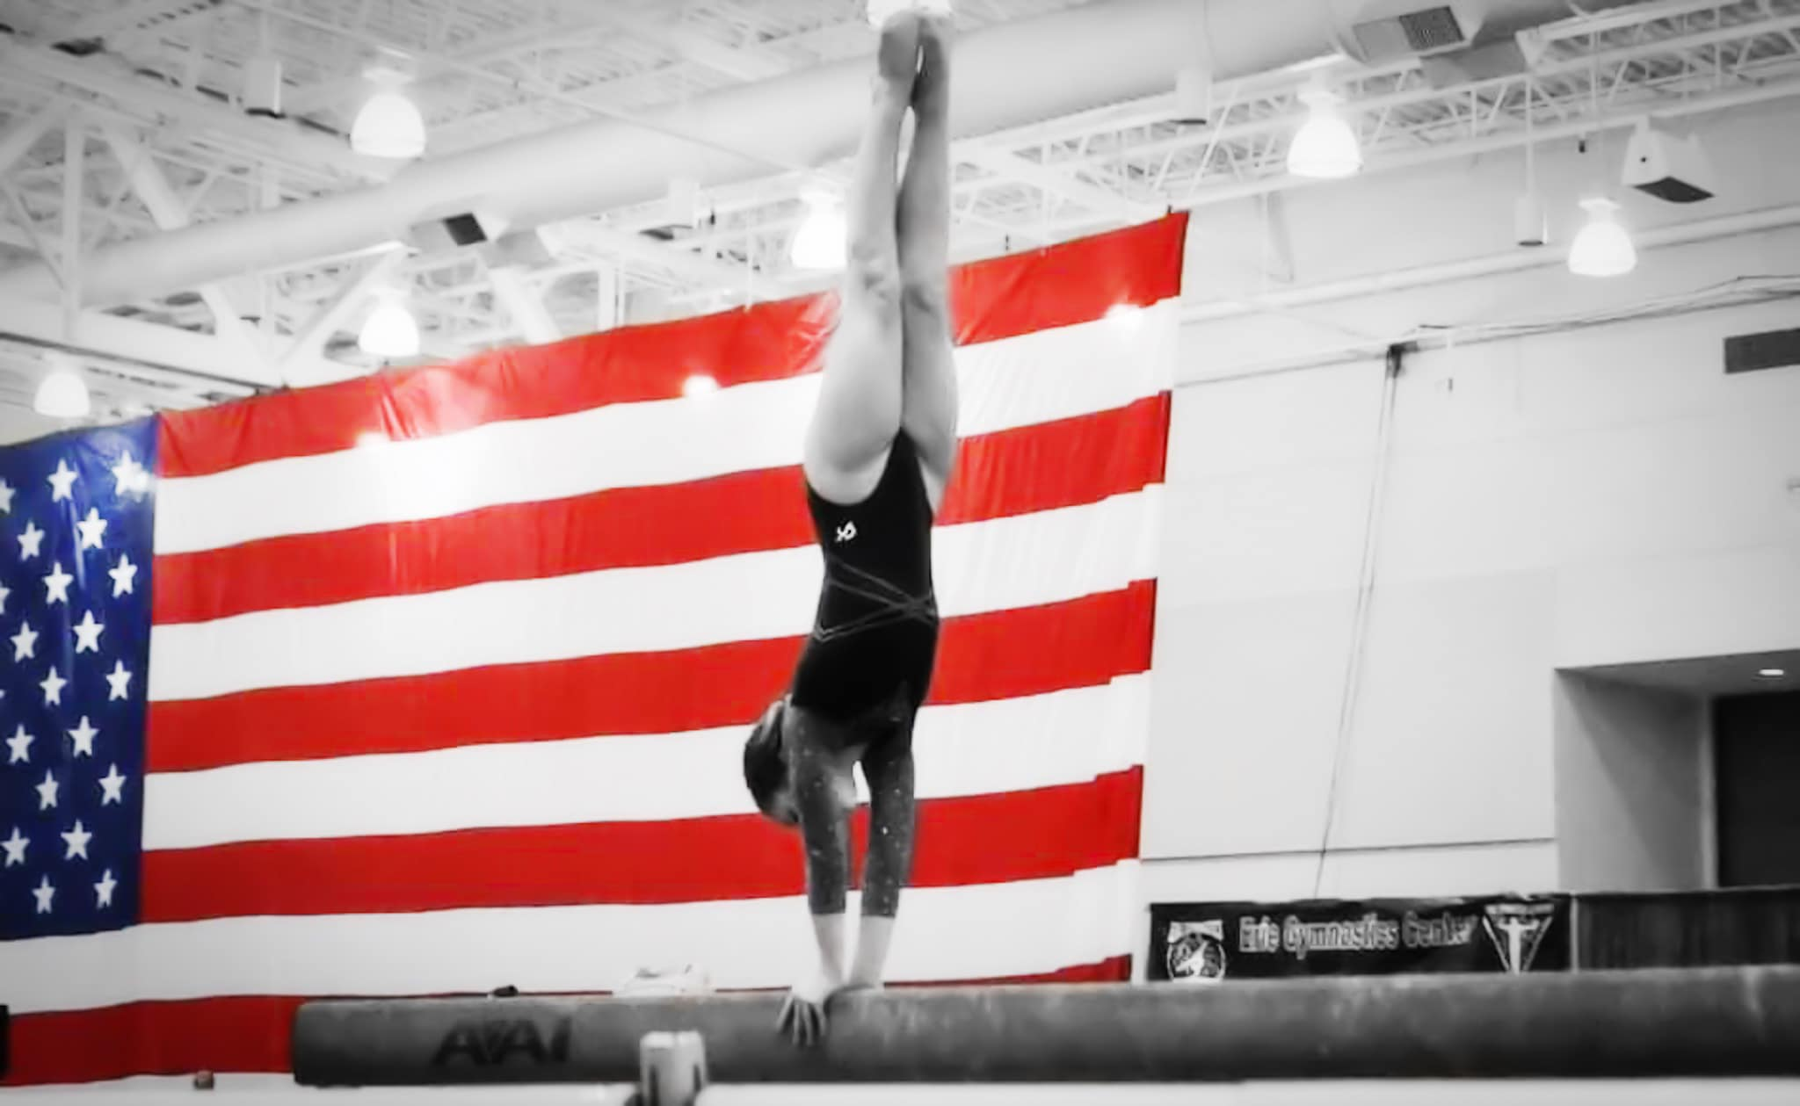
Team Camp
Camp is open to LEVELS 3-10

July 15 - 18
Day in the life of camp:
9:00 – 9:30 Stretch
9:30-10:00 Basics, Dance, Flexibility
10:00 – 11:00 Vault (Rotation 1)
11:00 – 12:00 Bars (Rotation 2)
12:00 – 1:00 Lunch & Games
1:00 – 2:00 Beam (Rotation 3)
2:00 – 3:00 Floor/Tramp (Rotation 4)
$315.00

*Girls are grouped by levels.
* Updated drills and skills for compulsories and optionals
*Team Building
*Mental Training
*Coaches training available
*Training in Vault, Bars, Beam, Floor, Tramp & Dance

Check out our website for registration forms.
www.greenvillegymnasticsacademy.com
Have questions? Call us at:
724-588-8166

LEVEL 2 - Advanced CAMP
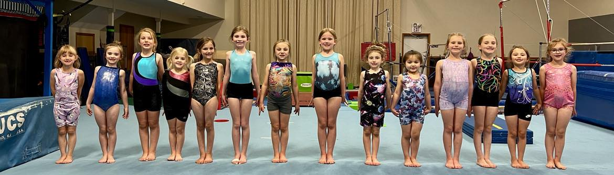
$145.000
Camp is open to ages five & up. Experience necessary.
Day in the life of camp:
9:00 – 9:30 Stretch
9:30-10:00 Basics. Flexibility, Body Shaping
10:00 – 10:30 Vault (Rotation 1)
10:30 – 11:00 Bars (Rotation 2)
11:30 – 12:00 Beam (Rotation 3)
12:00 – 12:30 Floor (Rotation 4)
12:30 – 1:00 Tramp (Rotation 5 )

July 22, 23, 25 9:00 – 1:00
Check out our website for registration forms.
www.greenvillegymnasticsacademy.com
Have questions ? Call us at:
724.588.8166
*Girls are grouped by levels.
* Updated drills and skills for the new compulsories
*Team Building
*Goal Setting
*Coaches training available
*Training in Vault, Bars, Beam, Floor, Tramp & Dance

Beginner – Intermediate Camp June 18 & 20
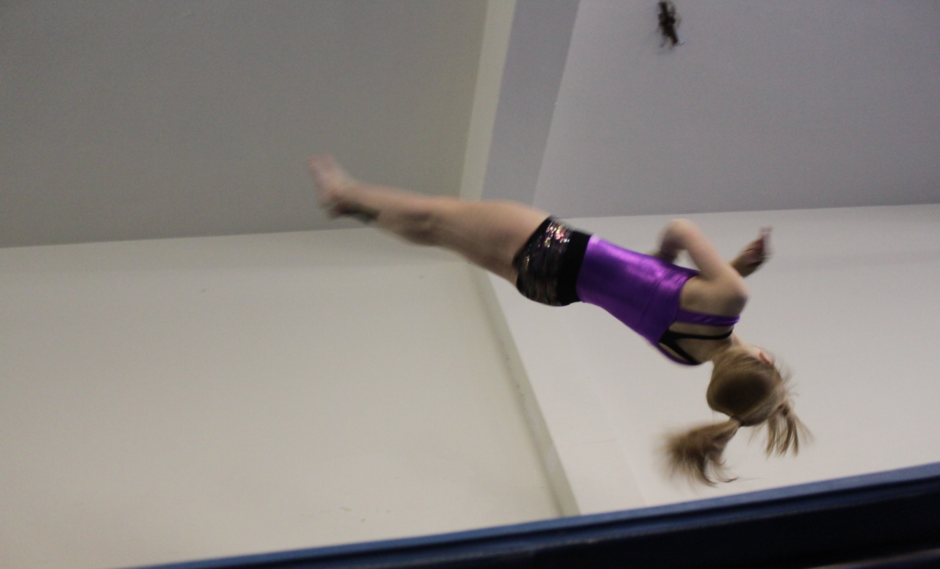
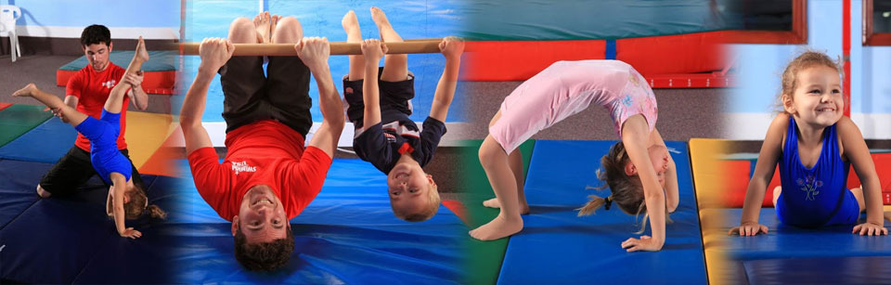
Day in the life of camp:
9:00 – 9:30 Stretch & Basics
9:30-10:00 Tramp & Floor
10:00 – 10:30 Vault (Rotation 2)
10:30 – 11:00 Bars (Rotation 3)
11:30 – 12:00 Beam (Rotation 4)

$95.00
Camp is open to ages four & up. No experience necessary.
Check out our website for registration forms.
www.greenvillegymnasticsacademy.com
Have questions ? Call us at:
724.588.8166
*Athletes are grouped by ability.
* Instruction Vault, Bars, Beam Floor and Trampoline
* Team Building Games
Non-members welcome!!

Trampoline & Tumbling Camp
*Spring Floor
*Foam Pit
*30 Foot Trampoline
*Overhead spotting system
*Air Track
*2 Mini Tramps
*Drill stations and more

Day in the life of camp:
9:00 – 9:30 Stretch
9:30-10:00 Basics, Jumps, Flexibility
10:00 – 10:30 Front Tumbling (Rotation 1)
10:30 – 11:00 Back Tumbling (Rotation 2)
11:30 – 12:00 Trampoline

Camp is open to ages six & up. No experience necessary.
$95.00
August 6 & 8

*Athletes are grouped by ability.
* Updated drills and skills
* Team Building
*Coaches training available
*Training in tumbling, Trampoline, and Jumps.
Cheerleaders and non-members welcome!!

Check out our website for registration forms.
www.greenvillegymnasticsacademy.com
Have questions ? Call us at:
724-588-8166

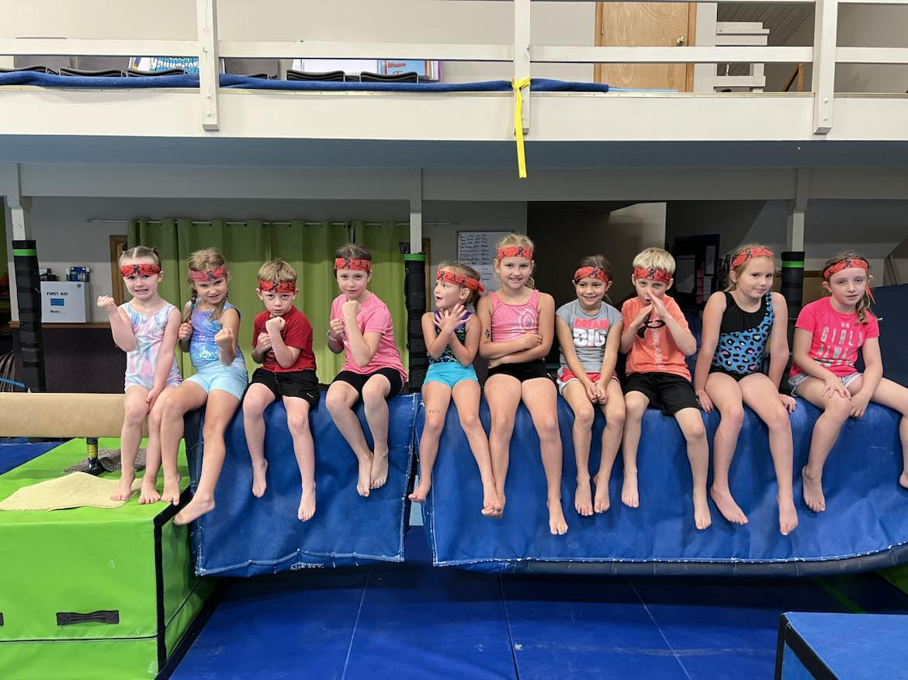
Ninja Camp
Camp is open to ages four & up. No experience necessary.
Check out our website for registration forms.
www.greenvillegymnasticsacademy.com
Have questions ? Call us at:
724-588-8166
$95.00
Day in the life of camp:

9:00 – 9:30 Stretch
9:30-10:00 Basics, Jumps, Flexibility
10:00 – 10:30 Obstacle course (Rotation 1)
10:30 – 11:00 Tramp & Tumbling (Rotation 2)
11:30 – 12:00 Open gym

JUNE 18 & 20

$95.00

